Project Name and Scenario
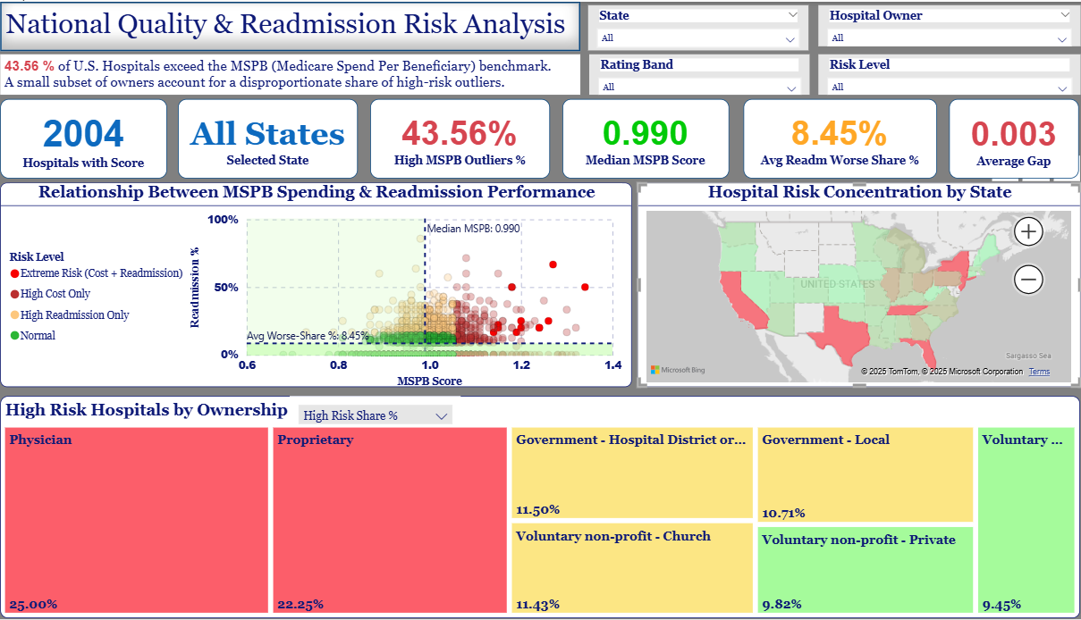

1.1 Project Name
Medicare Spending & Readmission Signals (Excel + Power BI)
1.2 Scenario
Hospital leaders need a simple way to see where Medicare Spending per Beneficiary (MSPB) is high, how it varies by hospital type/ownership/state, and whether quality signals (overall rating, readmission group results) point to drivers or trade-offs.
Task: Build a cost-and-quality view that flags outliers and actionable levers.

Stakeholders, Problem Statement and Sub-questions
1.3 Stakeholders
It's very important to know who we are speaking to because each group has different needs.
- CFO/Finance: identify high-MSPB outliers and peer benchmarks to prioritize cost-reduction work.
- Quality/Clinical Ops: see where “READM Worse” concentrations co-exist with high MSPB to target care-pathway fixes.
1.4 Problem statement
How can we pinpoint hospitals with unusually high Medicare spending per beneficiary and link those costs to hospital characteristics and quality/readmission patterns, so finance and quality teams can target interventions without compromising outcomes?
1.5 Sub-questions
- What is the national distribution of MSPB, and which states/types/ownerships show materially higher medians?
- Which facilities are high-MSPB outliers within their state and peer group (type + ownership)?
- Does a larger share of “READM Worse” measures correlate with higher MSPB at the facility level?
- How does MSPB vary by overall rating bands (e.g., low vs. high rating)?
- Which lower-MSPB peers (same state/ownership) look like practical benchmarks for each outlier?
- Are there geographic hot spots (states) where high MSPB and weak READM results cluster?

1.6 Final problem statement
How can hospital leaders identify facilities with unusually high Medicare Spending per Beneficiary (MSPB) and understand how spending patterns relate to hospital characteristics and quality outcomes, enabling targeted cost and quality improvement initiatives?

